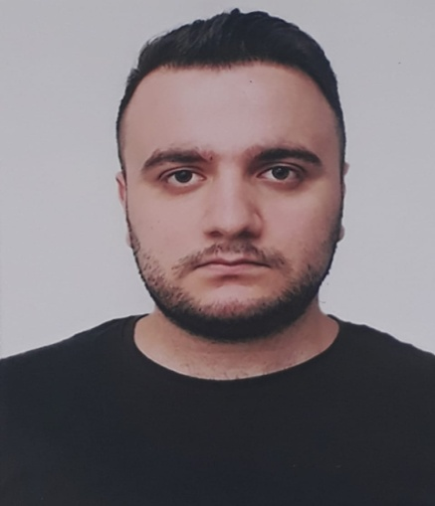 Orxan Məmmədov

PERSONAL INFORMATIONS

**+**99455 727 79 97

+99418 657 33 43

 orkhanmammadov14@gmail.com

Sumgait city, Jorat village, 72th block, flat 54A

Birth: 28 June 1996

EDUCATION

* 2019-2021 Azerbaijan Technical University at Mechanical engineering ( Dynamics and Robustness of Machines)
* 2014-2018 Azerbaijan State Oil and Industry University at Oil-Mechanical faculty
* 2003-2014 Sumgait city, the school of №10

EXPERIENCE, VOLUNTEERING EXPERIENCE and AWARDS

* ‘’Azertexnolayn’’LLC, mart - may 2017
* ATEF Group, february - may 2018
* Volunteer at the 2016 Formula 1 Grand Prix of Europe as Info Team Member at Zone 1/Baku City Circuit
* Volunteer at the Baku 2017 4th Islamic Solidarity Games as Host/Spectator Services at Baku Aquatics Centre
* Volunteer at the 2017 Formula 1 Azerbaijan Grand Prix as Grandstand Team Member/Spectator Sevices at Zone 3/Baku City Circuit

Computer Skills

* Microsoft Office (Word, Excel, PowerPoint)

Languages

* Azerbaijani - Native
* English - Intermediate
* Russian - Elementary
* Turkish - Native

Skills

* Time managment
* Problem solving
* Creative thinking
* Communication
* Teamwork
* Scheduling and calendar managment

Hobbies

* Walking
* To watch movies, videos and tv series
* To read articles