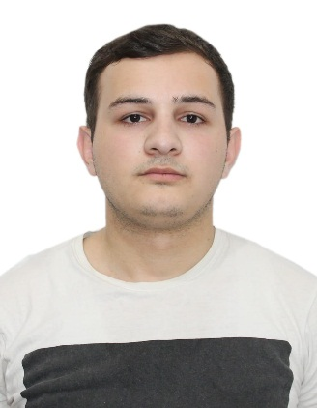 | Rauf İmanov
 | Date of birth: | 25.09.1996
 | Adress: | Baku, Nobel pr
 | Mobile: | (+994) 51 877-79-78
 | E-Mail: | rauf.imanov.1996@mail.ru
Experience
“Mansart Goup” MMC, July 2020 - Present time
Financer

“Təravət - 2019” MMC, February 2020 – July 2020

"Kombi-plus” July 2019 – February 2020
Financer
189 Taxi company , November 2018 – June 2019
Operator, Dispatcher
Paris Gallery , September 2017– August 2018
Security Manager
Education & Military Services
Azerbaijan Cooperation Univercity, Bachelor’s degree 2012-2016
General Economics- Accounting, control and analysis of economic activity
Baku, Narimanov district, secondary school 212, 2001-2012
Armed Forces of the Republic of Azerbaijan, Civil defense, Soldier 2016 -2017

Certification
Edu Company
1C-Accounting, October 2019– January 2020
ACCA F3 (Financial Accounting)
Baratsson, January 2019 – April 2019
World Students International Meeting
Moscow, June – July 2010
Edu Company
Mc Office Programs,October 2019– December 2019
Languages
Russian – Fluent
English – Fluent
Turkish – Fluent

Skills
Computer: Word, Excel, Powerpoint
DSMF and preparation unemployment report
BTP Program knowledge
Writing Tax invoice and electronical invoice
Ability to think analytically
Resistant to stress, Responsibility
1C Program knowledge
MIKRO Program knowledge
Courses
ACCA F3
Baratsson, January 2019 – April 2019
1c - Accounting
Edu Company, October 2019 – December 2019
Mc Office Programs
Edu Company, October 2019 – December 2019
Aditional Information
Hobby: Futbol,Film,Music

