**SHAHANA FATULLAYEVA**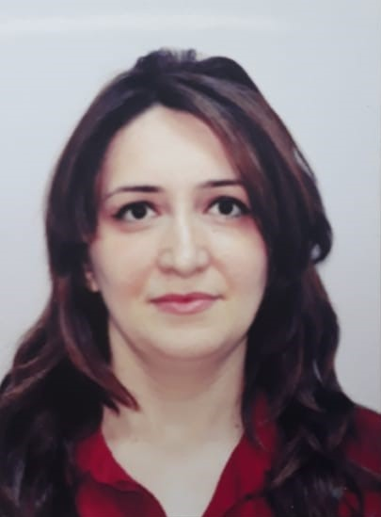

**A:** Rashid Ismaylov Street, Baladjary, Baku, Azerbaijan

**E**: sh_f@inbox.ru

**M**: (+994 55) 420 5 437

**PROFILE SUMMARY**

Detail-oriented and diligent administrative assistant/receptionist with 5 plus years of experience in financial and education industries. Possess excellent telephone and communication skills. I have extensive computer knowledge, including spreadsheet and word-processing programs at a high proficiency level. I am focused, consistent, punctual and reliable.

**COMPUTER SKILLS**

Amadeus Reservation System, MS Windows 11, 10, 7, XP, Vista, 98, 95, and MS Office 2003/2007/2010.

**QUALIFICATIONS**

2016 - 2017 ESOL (E3 L1), Sutton College, United Kingdom

2010 Certificate in Amadeus Booking System Training, Azerbaijan

2008 Microsoft Office Operator Certificate of Completion, Azerbaijan

**WORK EXPERIENCE**

**Zefer Education Centre (Azerbaijan) Sep 2022 – present**

Job Title: English Teacher

* Preparing students for University entry exams
* Ensuring students receive an appropriate level of language support

**Baltech Group Ltd (Azerbaijan) Apr 2018  Feb 2021**

Job Title: Executive Assistant

* Maintain office inventory and order supplies in a timely manner
* Manage purchases, invoices and ensure timely delivery of goods and payments.
* Greet and provide general support to employees/guests & visitors
* Greet and guide foreign visitors
* Receive and route business correspondence to correct department or staff member
* Coordinated travel accommodations for foreign staff
* Manage and maintain filing systems for electronic and hard copy documents

**Alfa Education Centre (Azerbaijan) Dec 2017  Apr 2018**

Job Title: English Teacher

* Teaching students how to read, write and speak English
* Preparing weekly lesson plans in accordance with syllabus guidelines
* Ensure students receive an appropriate level of language support
* Establish effective communication with students

**Cancer Research UK (Leatherhead, UK) Aug 2017  Nov. 2017**

Job Title: Shop Manager Assistant (Volunteer)

* Responsible for maintaining a high standard of merchandising and display of goods in the windows and the store whilst complying with CRUK guidelines
* Recommended merchandise based on customer needs
* Explained information about the quality and value of products
* Assisted with the shop housekeeping

**The Science Development Foundation Oct. 2011  June 2012**

**Under the President of Azerbaijan Republic (SDFA) (Azerbaijan)**

Job Title: Receptionist

Responsibilities included:

* Greeting visitors
* Informing coworkers of their visitors arrival
* Receiving and dispatching telephone calls
* Responding to queries promptly and in a friendly manner
* Receiving and recording letters and documents
* Receiving and sorting newspapers and magazines
* Registration of seminars
* Participation in the meetings
* Supervising library related works
* Producing quarterly reports
* Sending and receiving fax messages

**Technical Services Department of the MoD (Azerbaijan) Feb. 2003  Oct. 2004**

Job Title: Administrative Assistant

Responsibilities included:

* Schedule appointments
* Perform administrative tasks, such as copying and scanning
* Greet people visiting the office
* File and maintain records
* Schedule appointments and maintain appointment calendars
* Set up conference calls

**EDUCATION**

2003  2008 International University of Azerbaijan

Faculty of English Languages

Baku, Azerbaijan

**LANGUAGES**

**Reading Writing Speaking**

Azerbaijani Fluent Fluent Fluent

English Good Good Good

Russian Good Good Good