**PROFESSIONAL EXPERIENCE**

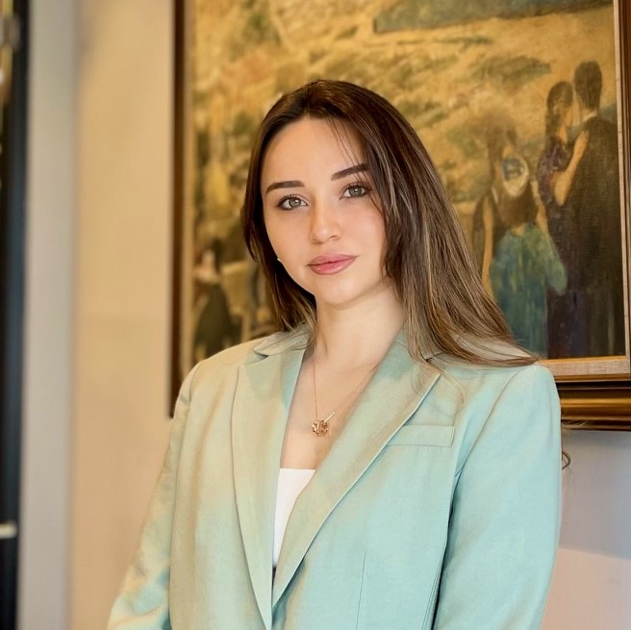

**Sevda Mammadova**

**About me**

Birthplace Baku

Date of birth 07/02/1994

**Contact**

**Address:**

Baku, Narimanov dist., I.Hasanoghlu 4

**Phone:**

+99450 607 44 37

**Email:** [sev.mmadova@gmail.com](mailto:sev.mmadova@gmail.com)

**LANGUAGES**

Azerbaijani - Native

Russian - Native

English – Intermediate

Turkish- Pre-intermediate

**Receptionist** at Deloitte & Touch LLAC

(23.10.2023-present)

* Work with incoming and outgoing telephone calls
* Provide assistance with office mailing and courier deliveries
* Perform other administrative duties or projects
* Meeting and greeting guests, verify their identify
* Preparing monthly reports, collating and filling expences
* Assist with arranging travel plans( such as tickets, hotels, accommodations,transfers,visa support documents,etc.) for all employees
* Also supporting Deloitte Academy by organizing training sessions and assisting trainers. My role ensures smooth coordination and facilitation of training programs, fostering learning and development within the organization.

**Voluntary Student Internship Program** at Buta Insurance OJSC

(2014)

**CERTIFICATES AND TRAININGS:**

* Business Management School- Human Resources Specialist (08.05.2024-09.06.2024). The subject of training was career and development, motivation and reward, HR metrics, recruitment and placement, labour code and etc.
* Buta Insurance OJSC & Michael Bang’s School of 5- Stars Sales – “Customer Service”(2014). The subject of trainings was Compulsory Insurance.

**EDUCATION:**

* Baku Slavic University (2011-2015)

English philology and literature

**SKILLS:**

* MS Office
* Adope Photoshop