CV

Karimli Aziz

Bakı ş. Ş.Məmmədova 11 m59  Home Phone: 012 561 92 68  Mobile Phone: +994 77 609 60 69  aziz.kerimli.98@gmail.com |  | Sex : Male  Birth Date : 07/05/1999  Marital Status : Single  Nationality : Azerbaijan  Driving Licence : BC | 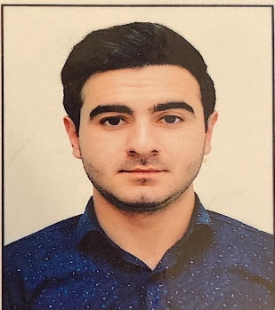

EDUCATION
University | Khazar Universtiy – Baku – Accounting and Audit – 09/2016 – 08/2020

WORK EXPERIENCE
05/2017 – Working  11/2017 | Smart Telecome – Accounting Assistant
01/2018 - Working  08/2018 | Nes Group – Product Manager
11/2018 - Working  07/2019 | Mustafa Tayat – Sales Manager
07/2019 - Working  04/2020 | World Telecom – Credit Specialist

ADDITIONAL EDUCATION & CERTIFICATES
11/2016 | Risk Management / Stimul Education
02/2017 | Accounting and 1C / Stimul Education
02/2017 | Academic English / Stimul Education
11/2018 | Principles of Marketing / Stimul Education
05/2019 | Human Resources / Stimul Education
10/2019 | General Management, Project Management / Stimul Education

COMPUTER SKILLS
Word, Excel, Powerpoint, Outlook: Excellent
Adobe Photoshop: Good
Corel Draw: Good
Adobe Aftereffect: Good

LANGUAGE SKILLS
English | Reading: Good, Writing: Good, Speaking: Good
Russian | Reading: Good, Writing: Good, Speaking: Beginning
Azerbaijan | Reading: Excellent, Writing: Excellent, Speaking: Excellent

