PERSONAL INFORMATION | FARHAD FARHADOV
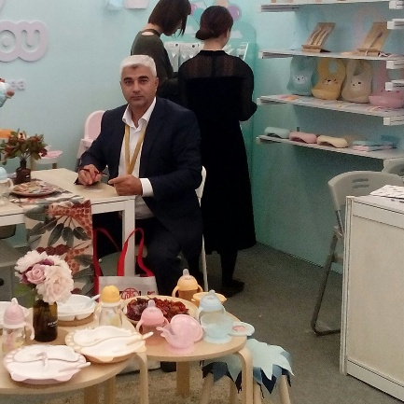 | Binagadi region, 28 May settlement, Baku, AZ1074, Azerbaijan
 | +99412 4094055 +99470 2657978
 | ferhad_ferhadli@yahoo.com
 | Skype: ferhad.ferhadli Watsapp: +99470 2657978
 | Sex Male | Date of birth 08/08/1978 | Nationality Azerbaijani

JOB APPLIED FOR
POSITION

WORK EXPERIENCE

(2012 - 2019)  (2010 - 2012)  (2008 - 2010) | Business manager
 | Pasha-K Company, Azerbaijan, Baku
- Overseeing daily business operations.
- Developing and implementing growth strategies.
- Training low-level managers and staff.
- Creating and managing budgets.
- Improving revenue.
- Hiring employees.
- Evaluating performance and productivity.
- Analysing accounting and financial data.
- Researching and identifying growth opportunities.
- Generating reports and giving presentations.

Business or sector Medicine, cosmetic products and baby foods

Assistant director
Balam LLC, Azerbaijan, Baku

- Assist in developing and implementing plans and goals for the department
- Work with the director to coordinate and supervise daily operations
- Ensure compliance with regulations and internal policies
- Monitor attainment of objectives
- Undertake staffing responsibilities (hiring, training, evaluating etc.)
- Assist in budgeting and monitoring expenses
- Maintain scheduling of events and represent the company when needed
- Create reports and submit them to the director or other executives
- Fulfil duties as assigned by the director

Business or sector Baby products

Office Manager
Pasha-K Company, Azerbaijan, Baku

- organising meetings and managing databases
- booking transport and accommodation
- organising company events or conferences
- ordering stationery and furniture
- dealing with correspondence, complaints and queries
- preparing letters, presentations and reports
- supervising and monitoring the work of administrative staff
- managing office budgets
- liaising with staff, suppliers and clients
- implementing and maintaining procedures/office administrative systems
- delegating tasks to junior employees
- organising induction programmes for new employees
- ensuring that health and safety policies are up to date
- using a range of software packages
- attending meetings with senior management
- assisting the organisation's HR function by keeping personnel records up to date,
- arranging interviews and so on.

Business or sector Baby products

EDUCATION AND TRAINING

(1999-2001)  (1995-1999)  1984-1995) | University  Baku State University  Master’s degree/Folklore and mythology  University  Baku State University  Bachelor’s degree/Philologist  Secondary school
 | Quba secondary school named after E.Bayramov

PERSONAL SKILLS

Mother tongue(s) | Azerbaijani
Other language(s) | UNDERSTANDING |  | SPEAKING |  | WRITING
 | Listening | Reading | Spoken interaction | Spoken production
English | B1 | B1 | B1 | B1 | B1
Russian | A2 | A2 | A2 | A2 | A2

Communication skills | - good communication skills acquired in the team thanks to my experience as an office manager

Organisational / managerial skills | - leadership  - strong organizational skills

Job-related skills | Economical use of finansal resorses

Digital skills | SELF-ASSESSMENT
 | Information processing | Communication | Content creation | Safety | Problem solving
 | İndependent user | İndependent user | İndependent user | İndependent user | İndependent user
Levels: Basic user - Independent user - Proficient user
Digital competences - Self-assessment grid
- good command of office suite (word processor, spread sheet, presentation software)
- windows
- computer formatting and software writing

Other skills | - Micro and Unity, 1C

Driving licence | BC (I have my own car)

