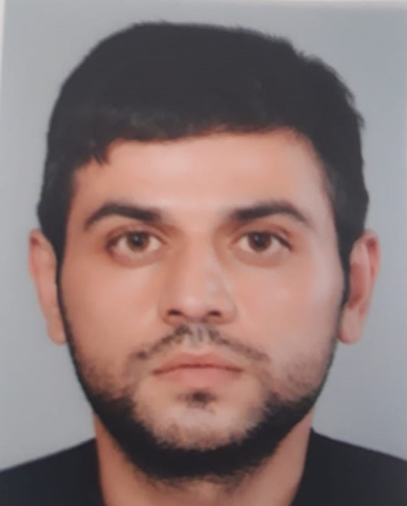 |  | QULUZADE FARIZ  Cashier Seller
Contact  PHONE:  +994705555909  EMAIL:  quluzadafariz@gmail.com |  | EDUCATION  High school No:258  1997 - 2008  Baku State University  2008 - 2012  Oriental Studies (Regional Studies in Arab countries)  WORK EXPERIENCE  Okean Auto Servis Manager  January 2020–March 2020  Acceptance, registration and departure of cars. Control over masters and service prices.  Languages  Languages:  Russian –Excellent  English-Excellent  Arabic-Good

COURSES AND TRAININGS
IELTS courses 6.0- 01.12.2014/02.06.2015
Lisanu Arab(Egypt Cairo)-2010/2011

Computer skills
MS WORD, MS EXCEL

