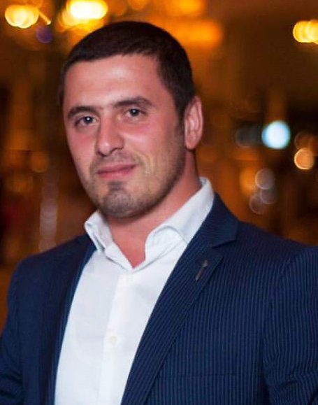**HABIB BAGIROV**

Date of birth: 31 may 1988

Citizenship: Azerbaijan

Marital status: Single

**Work experience**

________________________________________________________________________

«**ASSTRA FORWARDING** **AG» (Zürich)**

**International transport and logistics company**

07/2019- 03/2020 Trade Line Manager

02/2017- 07/2019 Forwarder

________________________________________________________________________

«**CARAVAN EXPRESS» MMC (Baku)**

**International transport and logistics company**

05/2015- 02/2017 Head of sales and marketing division

________________________________________________________________________

«**AMEQO» MMC (Kyiv-Baku)**

01/2015-05/2015 Head of Marketing Division

09/2014-01/2015 Brand Manager (NEMIROFF)

________________________________________________________________________

«**BAKU ELECTRONİCS» MMC**

04/2014 - 09/2014 HR / Leading Specialist

01/2014 - 04.2014 HR / Specialist

07/2013 - 01/2014 Director (Sahil branch) .

02/2013 - 07/2013Director (Merdekan branch)

10/2012 - 02/2013 Product trainer & Head sales manager

05/2009 - 10/2012 Sales manager

________________________________________________________________________

**«BAUMLER»**

06/2008-05/2009 Merchandiser & Sales manager

________________________________________________________________________

**«WORLD TELECOM»**

10/2005-10/2006Sales manager

**Languages** Azeri native

English pre-intermediate

Russian fluent

German: intermediate

Turkish: upper intermediate

**Comp. skills** Excellent knowledge of MS office, office hardware

**Interests/hobbies** Traveling

**Other** Punctual, adapt easily, ability to work with team and under pressure, ability to coordinate and manage multiple tasks and meet deadlines

**Contact numbers** +994 (55) 200-22-08

**Email address** baghirov.habib@gmail.com

**Certificates**  MS office 2008

MS office 2014

Driving license (A, B, C, E**)**