**Name Surname :** Samir Yaqublu

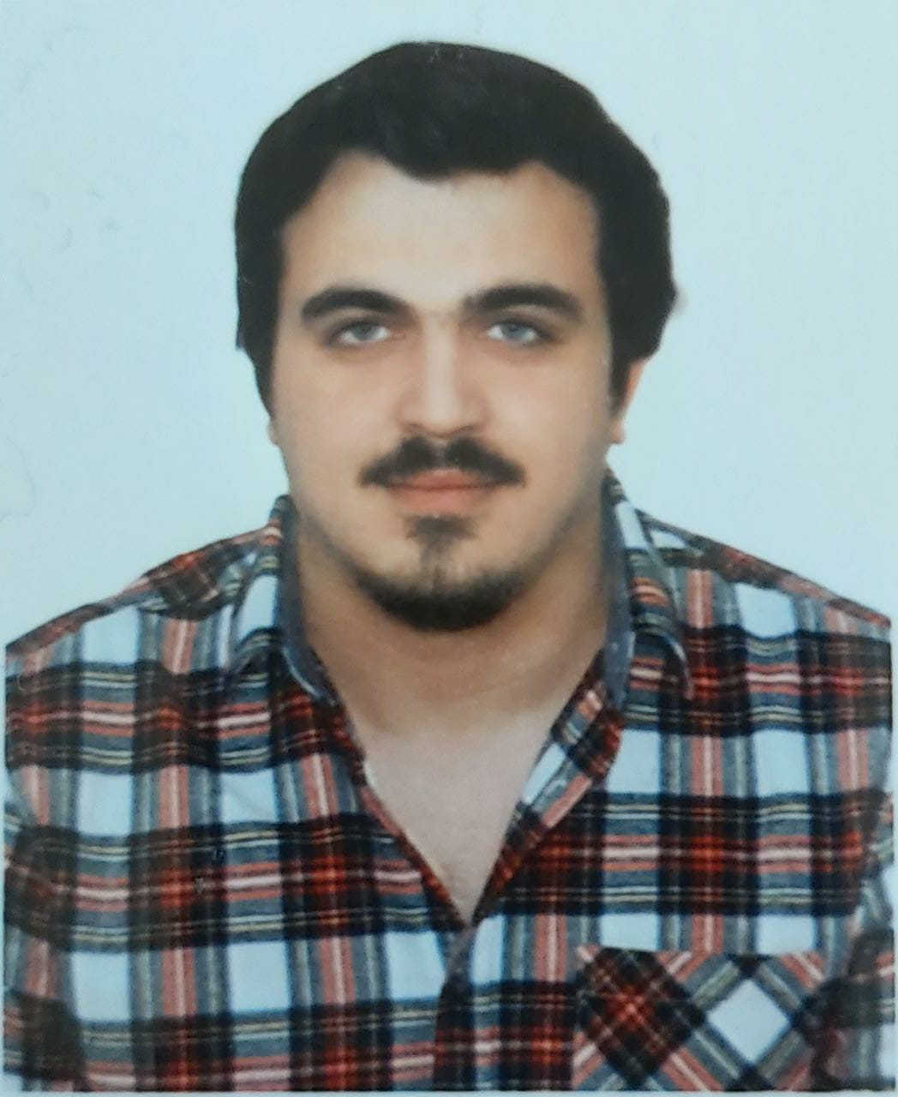

### Address : Rustavi Street, 21 Block, 21a/24 apt 4,

### Sumgayit,Azerbaijan

### Mobile Phone : +90 544 354 67 18

**E-Mail :** Yaqublu1907@gmail.com

**Education :** Master Degree **Date Of Birth :**01.08.1991

**Marital Status :** Single **Place of birth :** Baku

**Working Status :** Working **Driving Licence :**

**University  Ondokuz Mayıs University**   
Faculty of Engineering, Environmental Engineering

**High school** School №3 (Sumgayıt/ Azerbaijan)

**Computer Information** Microsoft Office Programs

**Internship AltaÇed Kayseri**

(2018) (Internship)(20 working day)

**Ondokuz** **Mayıs University**

Graduation Thesis-Waste Fuel Production

(Supervisor: Associate Professor Ayşe KULEYİN)

**Language English**

**Writing** (middle), **reading** (middle), **speaking** (medium).

**Russian**

**Writing** (middle), **reading** (middle), **speaking** (medium).

**Turkish**

**Writing** (high), **reading** (high), **speaking** (high).

**Azerbaijani**

**Writing** (high), **reading** (high), **speaking** (high).