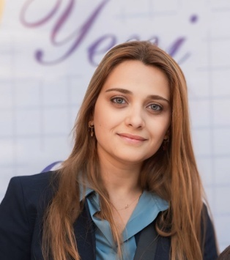 NARGİZ MAMMadova

Baku ,Azerbaijan

(994) 55 650 30 33

nargiz.novruzova@gmail.com

01.11.2024-present

Chief accountant

***ABADA (Azerbaijan International Road Carriers Association)***

23.09.2019-05.09.2024

Accountant Specialist

***Caspian Marine Service B.V***

February 2018 -20.09.2019

Chief Accountant

***Astexnoservis LLC***

***Job Description***

* Daily bookkeeping and accounting processes including:  payroll, bank reconciliation
* Execute monthly payroll activities
* Prepare Journal Entries for prepaid expense and deferred revenue
* Receive and deposit all revenue.
* Prepare monthly and quarterly financial reports, including standard financial reports, budget vs. actual reports and other financial reports.
* Monitor billing for compliance with all internal policies
* Financial reporting and other administrative requirements for management
* Reportandtrackexpenditures
* Income Tax
* Preparation of the VAT reports
* Preparation quarter and annual reports in fund of social insurance
* Preparation quarter and annual reports in Statistical committee
* Budgeting and Tax planning
* Execute month-end closing procedures and postings
* Coordinate with auditors in preparation of year-end audit

May 2014 Jan 2018

Accountant

***Astexnoservis LLC***

May 2011 Apr 2014

Accountant

***As Texnika LLC***

Jan 2010 Apr 2011

Accountant

***As Group LLC***

Apr 2008 Jan 2010

Accountant

***UPS LLC***

Sep 2006 Apr 2008

Accountant

***NABZ LLC***

Education

2009

Bachelor

*Azerbaijan State EconomicUniversity*

*Finance-credit*

Certificates

**Professional Accountant Certificate (PMS)**

**(1 stage completed successfully, 2 stage waiting for exams)**

**GRBS**

ACCA( Financial Accounting (F3) )

Skills

* Microsoft Office Programs
* SAP
* 1C (7.7)

Language skills

* Azerbaijan
* Russian
* English