**Curriculum vitae**

**COMMON INFORMATION :**

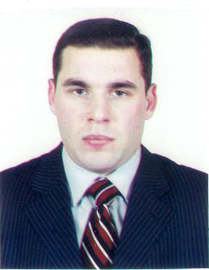

Name : Sharif

Surname : Mammadzadeh

Patronymic : Zahid

Family status : Married

Date and place of birth : 06-08-1982. Baku, Azerbaijan

E-mail : mamedzadeserif@gmail.com

Tel.: (+99451) 2019272 (+99450) 2262297; (+99455) 7886221; (070) 2152510

**EDUCATİON :**

Baku State Univerity Geology Bachelor 01.09.1999-30.06.2003

Baku State Univerity Geology-Seismology Master degree 01.09.2003-30.06.2005

**COMPUTER SKİLLS** :

MS Office programs, Internet user. High typing speed. Also there is an ability to get acquainted with all necessary programs (required at work) in a short period of time.

**WORK EXPERİENCE** :

2004 – 2006: Azerbaijan National Academy of Sciences, İnstitute of Radiation Problems (Senior laboratory assitant).

2006 – 2012 : Azercell LLC (Call-center operator, telemarketing, problem solving). Mainly evening and night shift work.

2008 – 2009 Encotec ( Engineer).

2012 – 2015 S.A. Company (Driver). Night shift work

2012 – 2015 Azerbaijan National Academy of Sciences (INIS Unit head).

2016 – 2019 : Embassy of Israel in Baku (Assistant, driver of administration department).

2019 – 2020 : Chinar transport and Khazar travel (Assistant, driver)

2020 untill present : Azericard MMC (Assistant - driver of administration department).

Starting from november 2021 untill august 2022 : Customer relations department. Operator at Willstream outsourcing company (mainly night shift work).

Starting from November 2023 untill present : British Embassy as a part-time casual driver, assistant (hourly paid).

**LANGUAGES** :

Azeri-Russian-English-Turkish

**P.S.**: There are a driving licence (B category) and a personal car (Hyundai Grandeur. Year 2008, Engine 3.3).