1. Personal detals 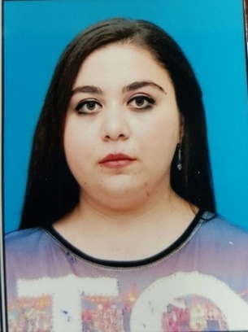

Name,surname:Yusufova Leyla

Date of birth:28.10.1994

Place of birth:Azerbaycan

Nationality:azərbaycanlı

Position applied for:Qeydiyyatçı\Daimi

Marital status:Subay

Adress:Bakı şəh.,Xətai ray.,Cavanşir küç.4

Phone number:0123730464\0558171119

Email:Yusufovaleyla@mail.ru

1. Education

|  |  |  |  |
| --- | --- | --- | --- |
| Name and locations of institute | Faculty | Specialty | Degree |
| Odlar Yurdu Universiteti | Təbiət və tətbiqi elmlər | Riyaziyyat və İnformatika müəl. | Bakalavr |

3.Work experience:

|  |  |  |
| --- | --- | --- |
| Dates | Position | Name of company |
| 20.09.2017\20.10.2017 | Menecer | Academy Group |
| 04.11.2017\04.12.2017 | Menecer |  |

4.Knowledge of language

|  |  |  |  |  |
| --- | --- | --- | --- | --- |
| Language | Reading | Writing | Listening | Speaking |
| İngilis | Yaxşı | Əla | Yaxşı | Yaxşı |
| Rus | Yaxşı | Orta | Yaxşı | Yaxşı |

5.Computer skills:Ms OFFICE

6.Other skills:

|  |  |
| --- | --- |
| Participant in training “First Summer Academy” | Volunteer |
| ATGT | Volunteer |
| SMM2016 Business Breakfast | Volunteer |
| AFFA | Team Leader |
| Baku Shopping Festival | Info team Volunteer |
| AGAT Schemes for Rio 2016 | Ceremony Volunteer |
| ASAN2 | Volunteer |
| ASAN School Sat Group | Volounteer |

|  |  |
| --- | --- |
| Baku2017 | SPS Volunteer |
| Beat Group Organizing Comiite | Volunteer |
| F1 2016 Grand Prix of Europe | Acreditation Volunteer |
| F1 2017Grand Prix of Azerbaijan | Acreditation Team Member |
| F12018Grand Prix of Azerbaijan | Uniform Volunteer |
| 13th World Scout Youth Form \14st World Scout Conference | Headphone Staff |
| SAF | Volunteer |
| AGF | Fan Club |

|  |  |
| --- | --- |
| ACB Absolute Championship Berkut;MMA | Volunteer |